District Logo | 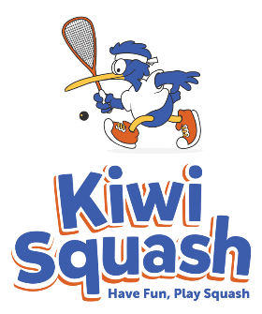

REGION KIWI SQUASH PROJECT
MEMORANDUM OF UNDERSTANDING (MoU)

An agreement dated
Between Squash District, Squash Club(s) and School

Purpose:
This MoU is tangible acknowledgement that Squash District, Squash Club(s) and School:
- Recognise they work towards mutually beneficial outcomes, and
- Wish to work together for success in a mutually beneficial manner that enhances each other’s contributions to those outcomes as outlined in the Kiwi Squash Project Plan Document.

There is to be a sense of shared purpose founded in quality relationships and open communication to help ensure that the activities of the parties are aligned and mutually reinforcing.

Roles:
Squash District, Squash Club(s) and School will carry out the activities as outlined in the Kiwi Squash Project Plan Document and are committed to sharing relevant information and resources. The parties are also committed to mutually supporting each other’s key strategies and programmes where synergies occur.

Agreement:
Squash District, Squash Club(s) and School have a shared commitment to this MoU.

Variation:
This MoU shall not be modified unless agreed upon by the listed representatives of each party. Any modification to this agreement must be signed and authorized by the listed representatives of each party.

Effective Date:
This MoU takes effect Day Date Month Year and will run until Day Date Month Year unless terminated earlier by any of the listed representatives of each party.

This MoU shall be reviewed annually / monthly or at such other time as may be agreed by each party.

Signatories:

Squash District: |  | Squash Club:
Signature |  | Signature
Name:  Date: |  | Name:  Date:

Squash Club: |  | School:
Signature |  | Signature
Name:  Date: |  | Name:  Date:

