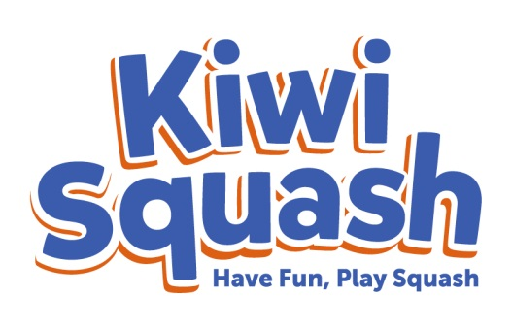



**Hi kids!**

**My name’s Nix…**



I hope you enjoyed playing all the fun games in Kiwi Squash. Can you please take a few moments to fill in this questionnaire**?**

**My name is ………………………………………………………………….………………………**

**I am …………………….. years old and in Year …………………………………………..**

**Did you enjoy Kiwi Squash?**

**It was okay**

**I loved it!**

**I didn’t really enjoy it**



**What didn’t you like about it?**

**What was the best thing about it?**



**Would you like us to contact you and your parents**

**with information about your local squash club?**

**Phone number ________________ Email ______________________________ _______________________________________**



**Hey kids, find me on Facebook at www.facebook.com/KiwiSquash!**

**Is there anything else you’d like to say?**