Thank you for participating in Kiwi Squash – please could you take a few moments to complete this feedback form so that we can continuously improve the programme
Teacher Feedback

School Name: _________________________________________________________
Teacher Name: ________________________________________________________
Email: _____________________________________________________________
Kiwi Squash Coordinator Name: __________________________________________
Coach(es) Name(s): _____________________________________________________
_____________________________________________________
School year(s) of children participating? 1 2 3 4 5 6 7 8 9
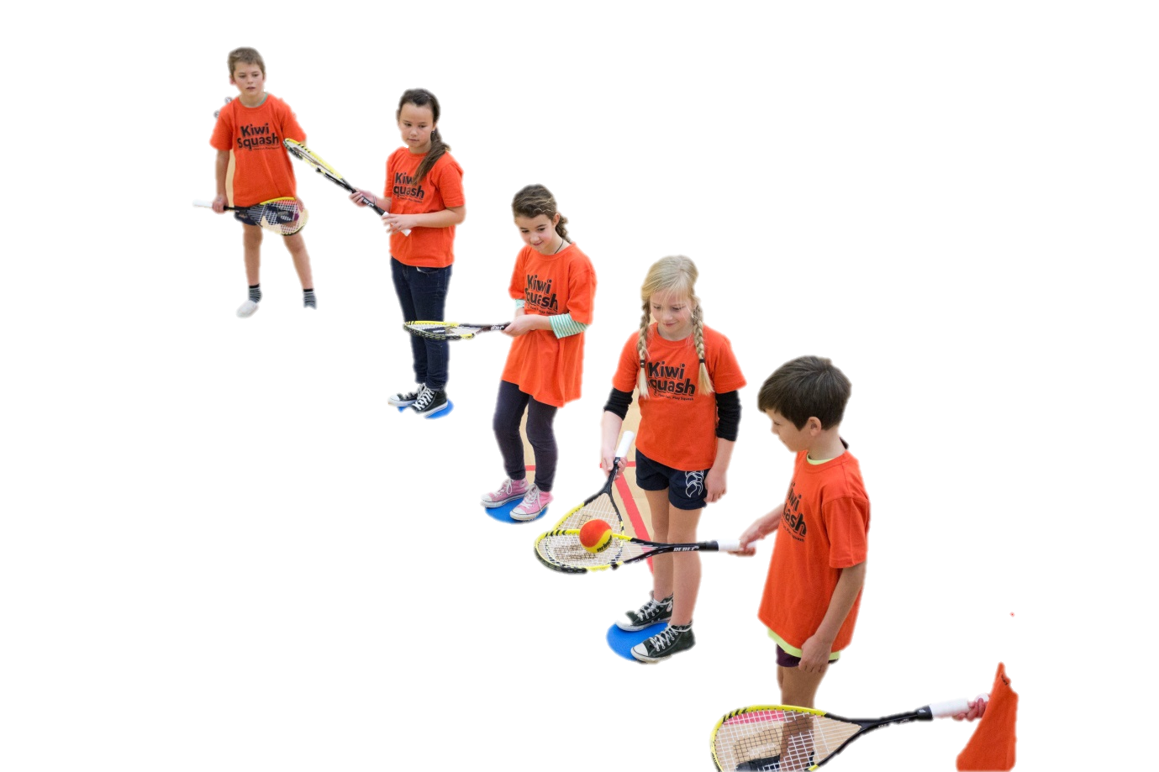
Term Kiwi Squash was delivered? Term 1 Term 2 Term 3 Term 4
What term would you ideally like Kiwi Squash to be delivered in? 1 2 3 4
Where did you hold your Kiwi Squash session?
- Sports Hall / Gymnasium
- Squash court at our school
- Squash court at local club: name of club _______________________________
- Outside (see question below)
- Other venue: details _______________________________________________
If outside, what type of surface?
- Artificial Turf Grass
- Concrete/Asphalt Paved area
- Other ________________________________________
Would you recommend Kiwi Squash to other teachers and/or schools? Yes No
Why/Why not? ________________________________________________________
________________________________________________________
________________________________________________________
Would you like to deliver Kiwi Squash again? Yes No
Check out Kiwi Squash on Facebook at www.facebook.com/KiwiSquash
Please rate the following aspects of Kiwi Squash…
 | Not worthwhile | Not so good | Good | Very Good | Excellent | Not applicable
Overall programme
Teacher training
Printed manual
DVD
www.kiwisquash.co.nz
Extra-curricular activities
Coach(es)
Kiwi Squash Coordinator
Equipment
Certificates
Communication

What was the best / most enjoyable aspect of Kiwi Squash?
_____________________________________________________________________
_____________________________________________________________________
_____________________________________________________________________
_____________________________________________________________________
_____________________________________________________________________

How could we improve the Kiwi Squash programme?
_____________________________________________________________________
_____________________________________________________________________
_____________________________________________________________________
_____________________________________________________________________
Thank you for your feedback on Kiwi Squash.
We appreciate you taking the time to help us deliver a
quality experience for young kiwis.
For any questions, queries or further information please visit www.kiwisquash.co.nz

